Forensic Anthropology Lab

Introduction
When skeletal remains are found, forensic anthropologists will take the bones and analyze them. They will use the different characteristics present to determine more about the individual the remains belong to, such as sex, age, height, etc. This helps investigators narrow down who those remains may belong to.

Today you will be taking measurements to determine how accurate forensic anthropology really is! You will be using the measurements from 3 different bones and plugging them into an equation to come up with a “predicted height” if just that bone was found. You will then compare those to the actual height to determine which bone is the best indicator.

Instructions
All measurements need to be made in centimeters. If you need a ruler, I have put a couple of printable rulers in our resources. You will have someone help you measure yourself and then you will measure them. Record all data below in the tables and complete math where instructed. There are two tables to fill out - the first one is based on traits, the second one is based on specific bones in the body. When you are done, answer the discussion questions that follow.

Data Collection

EXAMPLE TABLE: Note - You do NOT need to show your work in the table you fill in below this one. The math is just there in the example table to help you!

Trait | Measurement (cm)  Record your actual measurements here | Multiply by | Calculated Height (cm) from traits  Multiply your measurement by the number in the “multiply by” column to get this number | Difference Between Actual and Calculated Heights (cm)
Height | 172 cm | 1 | (172 x 1) = 172cm | (172-172) = 0cm
Palm width | 8 cm | 24 | (8 x 24) = 192cm | (192- 172) = 20cm

Have someone measure you.

TABLE 1: TRAITS

Trait | Measurement (cm)  Record your actual measurements here | Multiply by | Calculated Height (cm) from traits  Multiply your measurement by the number in the “multiply by” column to get this number | Difference Between Actual and Calculated Heights (cm)
Height |  | 1
Palm width |  | 24
Hand length |  | 10
Distance from  armpit to elbow |  | 8
Width of shoulders |  | 4
Head-to-chin length |  | 8
Outstretched arms |  | 1

TABLE 2: BONES - See the photos below the table if you don’t know what these bones are!

Bone | Measurement (cm) | Multiply by | Calculated Height  (cm) | Difference Between Actual and Calculated Heights (cm)
Length of Humerus |  | 3.08 (humerus length) + 70.45
Length of Femur |  | 2.38 (femur length) + 61.41
Length of Radius |  | 3.78 (radius length) + 79.01

Repeat with someone else – if at home you can do someone at home, work, or get numbers from someone else in our class.

Name of person being measured:

TABLE 1: TRAITS

Trait | Measurement (cm)  Record your actual measurements here | Multiply by | Calculated Height (cm) from traits  Multiply your measurement by the number in the “multiply by” column to get this number | Difference Between Actual and Calculated Heights (cm)
Height |  | 1
Palm width |  | 24
Hand length |  | 10
Armpit to elbow |  | 8
Width of shoulders |  | 4
Head-to-chin length |  | 8
Outstretched arms |  | 1

TABLE 2: BONES - See the photos below the table if you don’t know what these bones are!

Bone | Measurement (cm) | Multiply by | Calculated Height  (cm) | Difference Between Actual and Calculated Heights (cm)
Length of Humerus |  | 3.08 (humerus length) + 70.45
Length of Femur |  | 2.38 (femur length) + 61.41
Length of Radius |  | 3.78 (radius length) + 79.01

Humerus | Femur | Radius
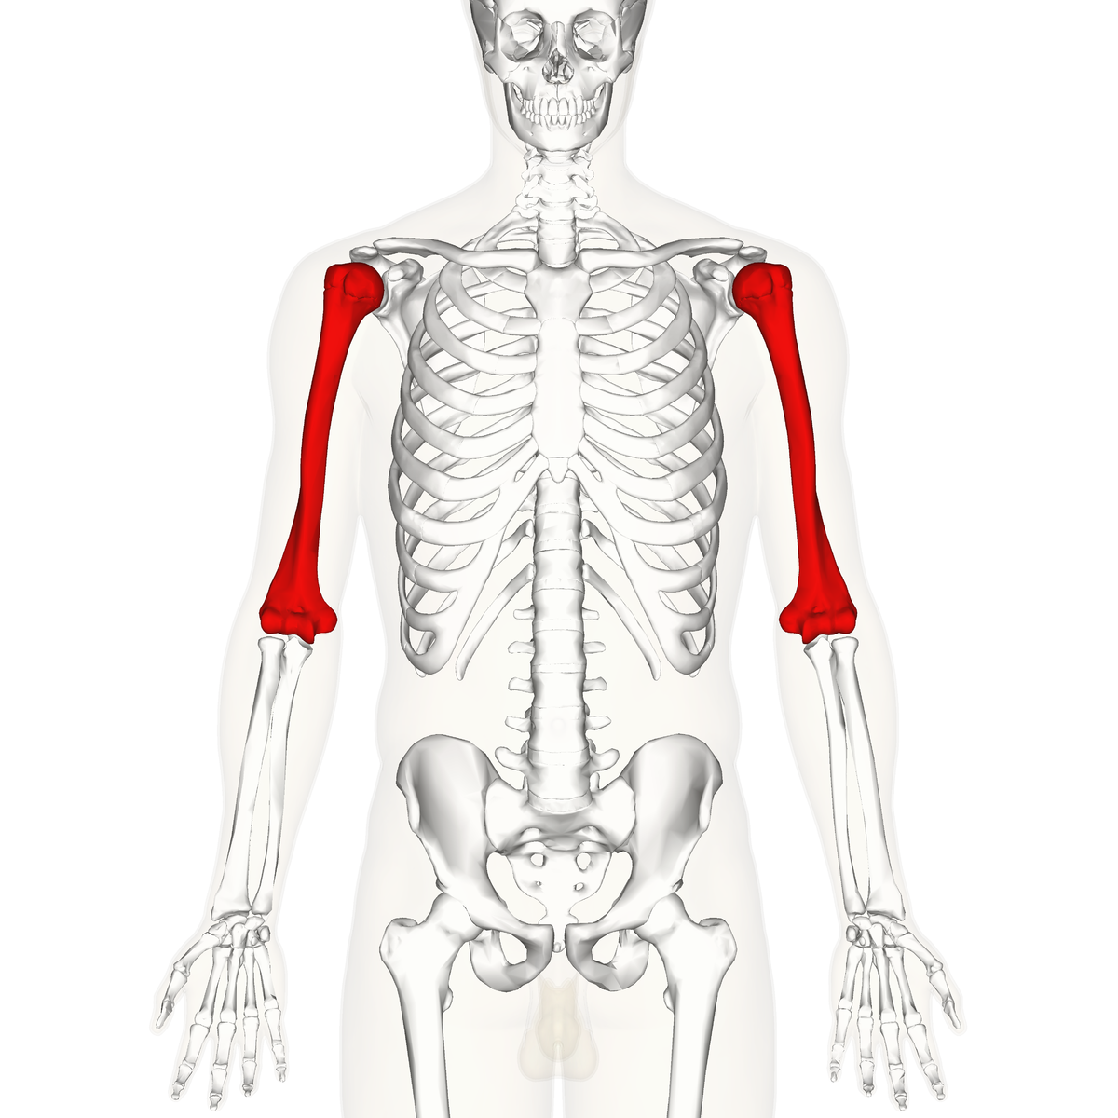 | 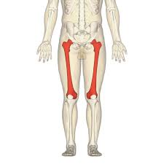 | 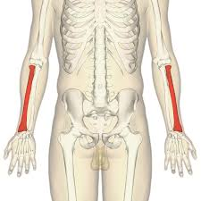

Discussion Questions:

- Which trait (besides the actual measured height) was the most accurate in estimating the height?

- Which trait (besides the actual measured height) was the least accurate in estimating the height?

- Which of the three major bones was the most accurate in estimating the height?

- Which of the three major bones was the least accurate in estimating the height?

