APES Review Worksheet
Modified from a document created by David Hong
- Use the axes to the right for the following:
Population
Time
  - Draw and label a line that represents linear growth.
  - Draw and label a line that represents exponential growth.
- List the four most populated countries in the world.
(1) (3)
(2) (4)
- Define the term ecological footprint

- Write an equation for the rule of 70:
- Perform the following calculations: (Show all of your work in a logical progression to the final answer.)
  - A city has a population of 50,000 in 2012. If the population of the city grows at an annual rate of 2%, the year in which the population will reach 100,000 is _____________ and the year it will reach 200,000 is _____________.
Show work:

  - A country’s population was 12 million in 1992 and in 2012 it is 24 million. If the population grew at a constant rate, that percent rate of growth was _____________.
Show work:

- Complete the following table by writing “high” or “low” in each box below.
Characteristic | More Economically Developed Counties (MEDCs) | Less Economically Developed Countries (LEDCs)
per capita GDP
degree of industrialization
infant mortality rate
per capita fossil fuel use
ecological footprint
greenhouse gas emissions
risk from heart disease
risk from infectious diseases
- Identify three examples of renewable resources and three examples of nonrenewable resources.
(1) (1)
Renewable: (2) Nonrenewable: (2)
(3) (3)
- Define the following:
  - total fertility rate

  - replacement level fertility

  - infant mortality rate

  - crude birth rate

  - crude death rate

- Describe the circumstances that will result in a Tragedy of the Commons.

- Describe an example of a Tragedy of the Commons.

- On the axes to the right, draw a line showing a population that exemplifies logistic growth. (s-curve) and label the carrying capacity.
Population
Time
- Perform the following calculation. Show all of your work. In a particular year a population has the following characteristics: the crude birth rate is 45, the crude death rate is 20, the immigration rate is 1%, and the emigration rate is 0.5%. The percent rate of growth for that year is __________.
Show work:

- Describe an example of a positive feedback loop.

- Use the axes below to draw and label lines representing the birth rate, death rate and total population size during the idealized demographic transition of a country. Include, written directly onto the graph, an explanation for each change in the birth rate, death rate and total population size.
Rate / Population size
Time
- On the axes below, draw and completely label four age-structure diagrams that represent slow growth, rapid growth, negative growth, and zero population growth (include labels on the x- and y-axes)
- Describe an example of a negative feedback loop.

- Arrange the following types of electromagnetic radiation in order from lowest to highest energy: Ultraviolet, Microwave, Infrared, Gamma, Radio, X-ray, Visible.

- List the following types of visible light in order from shortest to longest wavelength: Green, Orange, Red, Yellow, Blue, Violet.

- Identify three examples organic compounds and three examples of inorganic compounds.
Survivorship
Time
(1) (1)
Organic: (2) Inorganic: (2)
(3) (3)

- Using the axes on the right, draw and label three survivorship curves exemplifying early-loss, late loss, and constant-loss species.

- List three consequences of global warming.
(1)
(2)
(3)
- List three things you could do to decrease your contribution to global warming.
(1)
(2)
(3)
- List four greenhouse gases.
(1) (3)
Altitude (km)
Temperature (°C)
(2) (4)
- Use the axes to the right for the following:
  - Draw a line representing the Earth’s atmosphere.
  - Label each layer of the Earth’s atmosphere and identify where the greenhouse effect occurs and the ozone layer is situated.
- Humans began agriculture approximately ______________ years ago.
- A man-made product is also known as _______________________.
- The molecular formula of ozone is ________.
- In the box below, write out a series of chemical equations that illustrate the destruction of the ozone in the ozone layer.
- The acronym HCFC refers to _____________ _____________ _____________ _____________, which is:

- Identify three examples of biotic components of an ecosystem and three examples of abiotic components of an ecosystem.
(1) (1)
Biotic: (2) Abiotic: (2)
(3) (3)

- Complete the following table for these biogeochemical cycles:
Trait | Carbon | Nitrogen | Phosphorus | Water
Importance to life
Largest reservoir
Methods of transport
Cycle duration (long/short)
- Write the balanced chemical equation for photosynthesis in the box on the right.
Photosynthesis:
- The approximate age of the Earth is _______________ years.
- Write the balanced chemical equation for cellular respiration in the box on the right.
Cellular Respiration:
- Match the following:
  - generalist species Zebra mussel
  - specialist species Galapagos tortoise
  - invasive species American Alligator
  - keystone species Tiger salamander
  - indicator species Norway rat
  - endemic Species Giant Panda
- Define the term biodiversity.

- Define the term biome.
________________________________________________________________________________________________________________________________________________________________________________________________________________
- What determines the type of biome an area will have?

- Sketch and/or label the following on the map of the world below:
  - the equator
  - the tropic of Cancer and the tropic of Capricorn
  - the Mid-Atlantic Ridge
  - the location of suppressed upwelling characteristic of the occurrence of El Niño
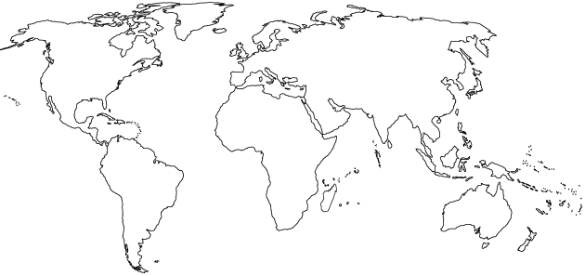
  - the location of China, India, Ethiopia, Brazil, Bangladesh, and Fremont
- Complete the following table:
Type of Biome | Typical Location | Typical Climate | Characteristic adaptations for survival
Tropical Rain Forest |  |  | Plants –  Animals –
Temperate Deciduous Forest |  |  | Plants –  Animals –
Taiga (Boreal) Forest |  |  | Plants –  Animals –
Tropical Grasslands (Savanna) |  |  | Plants –  Animals –
Temperate Grassland (Prairie) |  |  | Plants –  Animals –
Tundra  (Cold Grassland) |  |  | Plants –  Animals –
Desert |  |  | Plants –  Animals –
- Describe the circumstances that will result in cultural eutrophication.

- Explain the increasing concentration of carbon dioxide in the atmosphere leads to ocean acidification.

- Name the following:
NO NO₂
NO₂⁻ NO₃⁻
NO₂ N₂O
N₂ NH₃
NH₄⁺ HNO₃
NO_{x}
- In the box to the right, sketch a house and the surroundings of a house that is designed to make the greatest use of passive solar energy in the northern hemisphere. Include, inside the box, the location of both the winter and summer sun, and labels to indicate the compass direction that the house faces.
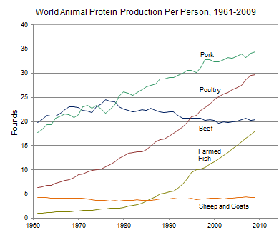
- Use the information in the diagram on the left, to answer the following:
  - The percent change in the per capita global production of protein from poultry between 1980 and 2000 was approximately ________.
  - The percent change in the per capita global production of protein from farmed fish between 1980 and 2000 was approximately ________.
  - The percent change in the per capita global production of protein from beef between 1961 and 2009 was approximately ________.
- The founder of the Sierra Club was ________ ________.
- Rachel Carson wrote the book ________ _________to raise people’s awareness of the harmful effects of the pesticide ________.
- The acronym ENSO refers to _____________ _____________ _____________ _____________, a phenomenon that occurs in the _____________ Ocean.
- Place the following nine events in chronological order, beginning with the most recent: the oil spill of the Exxon Valdez; the meltdown of the reactor at Chernobyl; the explosion of the Deepwater Horizon; the discovery of contamination at Love Canal; The first Earth Day; the leak of methyl isocyanate in Bhopal; the drafting of the Kyoto Protocol; the ratification of the Montreal Protocol, passage of the US Endangered Species Act.
(1) (4) (7)
(2) (5) (8)
(3) (6) (9)
- Strengthen this weak statement: “Fossil fuel use releases carbon dioxide, which causes the greenhouse effect.”

- The acronym BOD refers to _____________ _____________ _____________, which is:

- The acronym GMO refers to _____________ _____________ _____________, which is:

- Perform the following calculation. Show all of your work. If the grasses on a 100-hectare area of grassland grow at an average rate of 1 cm/day, the average volume of grass that is added to the grassland each day is ____________ m³. If the density of the grasses that grow in the grassland averages 400 kg/m³, the net primary productivity is approximately _____________ g/m²/day or _____________ g/m²/year.
Show work:

- Strengthen this weak statement: “Protecting endangered species like the Giant Panda costs too much and should be stopped.”

- Perform the following calculation. Show all of your work. A 40 m² solar array is installed on a house where the average insolation is 6 kWh/m²/day if the average total electricity output of the array is 1.2 kWh/hr; the efficiency of the array is ____________.
Show work:

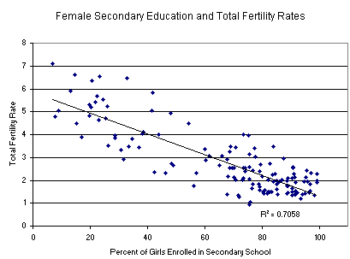
- Consider the graph on the right and explain what can be inferred from the data it presents.

- The first National Park was ________________ National Park.
- Match the ten most populous urban areas in the world with its respective continent:
Seoul
  - Asia Mexico City
  - N. America New York City
  - S. America Mumbai
  - Africa Jakarta
  - Australia Sao Paulo
  - Europe Delhi
  - Antarctica Osaka/Kobe
Shanghai
Tokyo
- Define the following…
Watershed:

Clean Air Act:

Clean Water Act:

Clean Drinking Water Act:

El Niño:

Baghouse filter

Electrostatic precipitator:

Dioxin:

- List three sources of methane that are amplified by human activities.
(1)
(2)
(3)
- The box to the right contains a crude depiction of a mountain, use it to sketch and label the essential atributes of a rain shadow. Include labels for the direction of the prevailing winds and nearest ocean.

- NO₂ is converted to N₂ and O₂ in a _____________ _____________, which also converts _____ to _____.
- Explain the causes of an urban heat island.

- Perform the following calculations: (Show all of your work.)
  - A rectangular area of forest that measures 10 thousand meters by 300 thousand meters has an area of ___________ square kilometers and ___________ hectares.
Show work:

  - A 60-Watt light bulb that is used for an average of 4 hours each day uses ___________ kilowatt-hours of electricity per year.
Show work:

- List two characteristics of an r-selected species.
(1) (2)
- List two characteristics of a K-selected species.
(1) (2)
- A Pacific Yew is a/an ____________ and it is endangered because of the following:

- A Piping Plover is a/an ____________ and it is endangered because of the following:

- An Orangutan is a/an ____________ and it is endangered because of the following:

- A Dodo was a/an ____________ and it is extinct because of the following:

- Complete the following table:
Ecosystem Component | An economically valuable ecosystem services it provides
honey bee
water cycle
forest
bat
bacteria
coral reef
wetland
- A company is importing rare tropical hardwood to manufacture furniture, list three laws, regulations, treaties, or acts that the company may have violated.
(1)
(2)
(3)
- Whaling is justified in the name of ________________ research, by the countries of ___________ and ___________.
- Two islands, different distances from the mainland have different rates of extinction, this is explained by the theory of island ________________________.
- ________________________ is a technique typically used to harvest scallops, crabs, and shrimp from the sea floor.
- A fishing practice that is commonly used to catch large solitary species of fish and was featured in The Perfect Storm is ________________________.
- _____% of the Earth is covered with water. Of all the water on Earth _____% of it is saltwater, _____% is frozen, and _____% is available and relatively accessible.
- Arrange the following particles in order of smallest to largest: clay, sand, silt
(1) (2) (3)
- To live a healthy, active life most adults need to consume approximately ___________ calories of food each day.
- Arrange the following foods in order of highest to lowest in terms of global production: corn (maize); rice; wheat.
(1) (2) (3)

- List four innovations that led to the Green revolution.
(1) (3)
(2) (4)
- Match the following:
  - anemia iron deficiency
  - goiter vitamin A deficiency
  - scurvy vitamin D deficiency
  - rickets iodine deficiency
  - blindness vitamin C deficiency
- Use the axes below to draw and label an illustration of the pesticide treadmill.
Pest Population
Time
- Explain how the biomagnification of DDT led to the (near) demise of the Bald Eagle population in the US.

- List three things you could do to conserve water.
(1)
(2)
(3)
- Perform the following calculations: (Show all of your work.)
  - A family of 5 replaces a 6-gallon/minute showerhead with a new 2-gallon/minute low-flow showerhead. If every member of the family takes one 10-minute shower per day, the family will save ___________ gallons of water in one year.
Show work:

  - A family has a rectangular swimming pool that measures 15 feet by 20 feet. If water evaporates from the pool at a rate of 50 gallons per square foot per year and a pool cover will reduce evaporation by 90 percent, the family can save ___________ gallons of water per year by using a pool cover.
Show work:

- Define the following:
pH:

Turbidity:

Water hardness:

Biological oxygen demand:

Organic waste:

Cholera:

Schistosomiasis:

Giardia:

- Completely label the following diagram of a sewage treatment plant and list the items removed at each step.

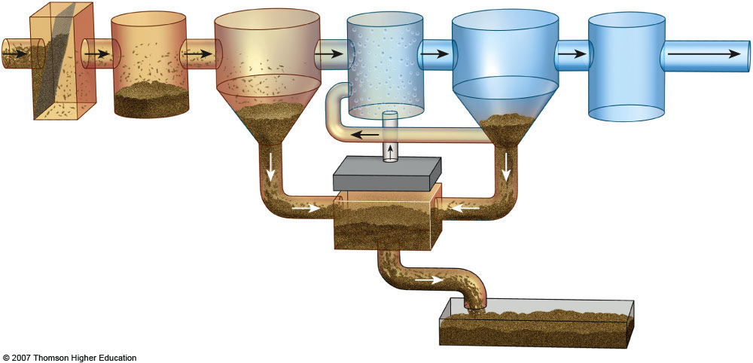

- In the box to the right, list the ranks of coal in order from highest to lowest energy content. (indicate the direction in the box.)
- List three air pollutants that are emitted during the burning of coal.
(1) (2) (3)
- List seven products that are derived primarily from crude oil:

- The acronym OPEC refers to _____________ _____________ _____________ _____________, which is important because:

- Fracking is a common name for ______________ ______________ and it is a concern because…

- Explain what the Deepwater Horizon was, where it went, and why it is significant.

- The acronym ANWR refers to _____________ _____________ _____________ _____________, which is important because:

- Perform the following calculations: (Show all of your work in a logical progression to the final answer.)
  - A family has a total of 1500 Watts of light bulbs throughout their house, if they replace them all with LED light bulbs, which use 90% less energy, the family will now use _____________ Watts of electricity.
Show work:

  - A space heater operates at 1500 Watts, if it is used for 10 hours each day for one week and the cost of electricity is 20 cents per kilowatt-hour, it will cost _____________ to operate the heater for the week.
Show work:

- The acronym CAFE refers to _____________ _____________ _____________ _____________, which is important because:

- List two species that may be threatened by the construction of a solar power tower in the California Desert.
(1) (2)
- ________________ is the active element in most photovoltaic cells.
- List four things you could do to conserve energy.
(1)
(2)
(3)
(4)
- State where Chernobyl is located and explain what happened there.

- Complete the following chart.
Mining Technique | Description | Environmental consequences
Open-Pit mining
Subsurface mining
Strip mining
Mountaintop removal
Drilling
- Strengthen this weak statement: “Mining causes pollution that may disrupt the environment.”

- Match each of the following elements with its ore:
  - aluminum galena
  - iron quartz
  - uranium bauxite
  - lead hematite
  - silicon pitchblende
- Explain what happened at Three Mile Island, and why it is significant.

- Explain how thermal pollution is produced by power plants.

- Explain what happened at Fukushima Daiichi and why it is significant.

- Perform the following calculation. Show all of your work. A radioactive cloud may contain Iodine-131, which has a half-life of 8 days. If the waste must decay to a concentration of less than 0.1% to be considered safe, it will take approximately ______ days to reach safe levels.
Show work:

- Perform the following calculation. (Show all of your work in a logical progression to the final answer.) A family has a 75 m² solar array on their house, which has an efficiency of 10%. If the average insolation on their array is 6 kWh/m²/day and their average cost of electricity is 20 cents per kilowatt-hour, the family has the capacity to produce _________ worth of electricity daily, and _________ annually, from the sun.
Show work:

- For each of the following substances, draw an arrow that points to an unambiguous location along the line, below, representing pH: orange juice; normal rain; ammonia; lime (calcium carbonate); sulfuric acid; acid rain; human blood.

1 2 3 4 5 6 7 8 9 10 11 12 13 14
pH
- Explain what evapotranspiration is and why it is significant.

- What is different about growing plants hydroponically?

- In the box below, write a series of chemical reactions that leads to the formation of tropospheric ozone in photochemical smog.
- The acronym POP refers to _____________ _____________ _____________ which is:

- Explain what a watershed is and why it is significant.

- List two environmental benefits of wetlands.
1)
2)
- In the box to the right, draw a diagram that illustrates how electricity is produced by a dam
- List four characteristics that will result in waste being classified as “hazardous”
1) 3)
2) 4)
- Explain what an El Niño event is and why it is significant.

- What is a wet scrubber and how does it work?

- What is an electrostatic precipitator and how does it work?

- In the box below, write a series of chemical reactions that leads to the formation of acid rain.
- Kwashiorkor is
- Marasmus is
- If the cost of gas is $3.50 per gallon and the average gas mileage of a car is 25 mpg, the cost of driving the car per mile is _____________ $/mi, or _____________ ȼ/mi.
Show work:

- The acronym NIMBY refers to _____________ _____________ _____________ _____________ _____________, which is:

- Identify significant sources of the following air pollutants:
Formaldehyde:
Radon:
Mercury:
Carbon monoxide:
Nitrous oxide:
- List three specific health effects of lead on humans.

- What was the Green Revolution and why is it important?

- Label the four major zones of life in the appropriate areas on the diagram representing a temperate lake in the box to the right.
- For each of the following biomes, identify a specific country in which each biome occurs in relative abundance:
Taiga Desert
Tropical rainforest Temperate grassland
Tropical grassland Coral reef
Temperate deciduous forest Tundra
- List three disinfectants that are commonly used to make drinking water safe during in the water treatment process.
1) 2) 3)
- In the box below, write the chemical equation for the formation of carbonic acid from the reaction of water with carbon dioxide.
Identify two places in the environment where the above reaction occurs naturally.
1)
2)
- Sketch and/or label the following on the map of the world below:
  - the equator
  - the Mediterranean Sea
  - the Ogallala Aquifer
  - the island of Mauritius (where the Dodo once lived)
  - the location of Saudi Arabia, Indonesia, Philippines, Panama, Iceland, California

