APES REVIEW GUIDE

AP exam is May 10, 2018 at noon!
Table of Contents

Part 1: Managing your Time
Six Week Study Plan | pg. 2

Part 2: Keys to passing the APES exam
Multiple Choice | pg. 3
Free Response Tips | pg. 4
The Math | pg. 5
Experimental Design | pg. 5
Graphing | pg. 5
Major APES Themes | pg. 6
Exam Topic Outlines and weights | pg. 6

Part 3: Review Questions and Vocab Lists
Earth Systems | pg. 11
Living World | pg. 18
Populations | pg. 24
Land and Water Use | pg. 28
Energy Use and Consumption | pg. 34
Pollution | pg. 39
Global Change | pg. 46

Part 4: Case Study Connections
Case Studies | pg. 49

Part 5: Reference Sheets
Must know math | pg. 61
Metric system | pg. 62

The six-week study plan
Use this calendar to help you systematically prep for the AP exam. If you are a quick studier, use the lower suggested time. If you take more time studying, use the higher suggested time. You can also study other items such as the review books and apps. I suggest you cross off or highlight items on the chart as you do them. It’ll motivate you to see your progress!
Study tips: Eliminate distractions. Put your phone in another room. Don’t watch TV or have social media/games open on the computer while you use it. Listen to classical or soothing music or none at all. Find a quiet area. Eat a healthy snack for brain power
 | Week 1  April 2 | Week 2  April 9 | Week 3  April 16 | Week 4  April 23 | Week 5  April 30 | Week 6  May 7
Time per day | 15-30 min | 15-30 min | 15-30 min | 30-60 min | 30-60 min | 60-90 min
Topics to review | Ecology | Earth systems, Soil and Agriculture | Human Populations, Toxicology & Waste | Energy and Mining | Air and Water pollution | Everything
Look over unit notes & memorize vocab* | Unit 3, 4, 6 | Unit 2, 5 | Unit 1, 7, 8 | Unit 9 | Unit 10, 11 | Difficult topics you ID’d during review unit
Practice FRQs | 2000 #3  2010 #2  2014 #4 | 2009 #4  2005 #2  2004 #4 | 2008 #4  2003 #2  2000 #4  2008 #2 | 2012 #1  2011 #1  2009 #2  2008 #3 | 2013 #1  2011 #2  2007 #3  2006 #2
Spend extra time on these concepts | Nitrogen cycle, succession, primary productivity, invasive species | El Nino, soil texture, salinization, desertification | Population graphs and math, Bio-accumulation, IPM | Energy pros and cons; math; env. Impacts of mining | Eutrophication, water quality testing, climate change, pollutant source and effect
Fast track to a 5 | Ch. 9, 10, | Ch. 5, 6, 8, 12, 13 | Ch. 11, 14 | Ch. 15, 16, 17 | Ch. 7, 18, 19 | Environ. Laws
Bozeman science videos** | 001, 007, 008, 009, 010, 011, 012, 035 | 002, 003, 006, 016, 017, 018 | 013, 014, 015, 021, 031, 032 | 019, 022, 023, 024, 025, 026, 027, 028 | 004, 005, 020, 029, 030, 033, 034
Review book section | Part 2 | Part 1 | Part 3 | Part 5 | Part 4, 6, 7
*As you look back at the material, highlight or make note of the topics you have trouble remembering. You can ask for help during class and focus your studying in the end on the harder topics.
** Bozeman website: http://www.bozemanscience.com/ap-environmental-science
Keys to Passing the APES Exam
About the Exam: The exam is three hours long, 90 minutes for 100 multiple choice questions and 90 minutes for four free response questions. The multiple choice section is worth 60% of your score and the free response makes up the remaining 40%. Bring a small clock or wrist watch to carefully monitor your time. You may not use a calculator for this exam. In early June, the free response questions are scored by college professors and highly qualified high school teachers at the AP Reading. These test are posted to the College Board website, where teachers and students can down load the questions and the scoring guides.
Succeeding on the Multiple Choice Questions The multiple choice questions cover a broad range of topics, therefore to succeed you will need a solid background in Environmental Science. The Themes and Topics are in this document. There are six underlying themes and seven major topics. The topics have a percentage which is a general guide for the number of questions out of the 100 multiple choice questions. Below are some general test-taking skills that should help you on this section.

- Read each question carefully. This is as much a reading test as it is a science exam. You will have an average of 54 seconds for each multiple choice question, one hundred questions in ninety minutes.

- To guarantee the highest number of correct answers, start by reading the whole test and answering only the questions that you know the answer to immediately or with a minimum of thought. Go all the way to question number 100, even though you probably are skipping quite a few. Time saved here can be used later to answer the questions that are more difficult. Be very careful that your responses on the answer sheet match the number of the question you are answering, that is you are bubbling the correct number.

- There is a penalty for guessing. The scoring formula will subtract ¼ point for each incorrect answer while adding 1 point for each correct one. Random guessing to fill in your answer sheet will probably result in a lower score. If you can eliminate two or more choices as being incorrect, it is to your advantage to take an informed guess. Statistically, if you guess at four questions and get three wrong and only one right, you will still add ¼ of a point to your score.

Free Response Questions Hints
Overview of the types of questions
There are three types of questions. An Analysis of a Data Set question where you interpret graphs, maps or charts. One Document Based question, you will have to read a document and answer questions based on that information as well as your general knowledge. There are two Synthesis and Evaluation questions. These questions may ask you to indicate the relationship between two or more concepts. If you do not know the relationship between the concepts, at least tell what you do know about them individually. Sometimes these questions will include experimental design.

Each question is graded on a 10-point scale. Some of the grading rubrics are set up to contain slightly more than 10 points (e.g., 11-13). However, you can only earn a maximum of 10 points on any one question. Remember, there are no calculators allowed. Use a ballpoint pen with dark black ink.

Succeeding on the FRQs
The questions are in two different books. The answer booklet will be the one shipped back and graded. The question booklet will be returned to you 48 hours after the exam. The question booklet is a great place to organize your notes, outline your answer and make some calculations. Only answers written on the answer booklet will be graded. The national average for the essay section will be about 50% correct (i.e., 5/10). It is very likely that you will not know everything, this is expected, but it is very likely that you do know something about each essay, so relax and do the best you can. Don't panic or get angry because you are unfamiliar with the question. Often they’ll pick topics from the news that you may or may not be familiar with. You probably have read or heard something about the subject - be calm and think... look for classroom connections to the topics and use those clues to guide your answers.

- Don't leave questions blank. Each point you earn on an essay question is the equivalent of two correct multiple-choice questions, and there is no penalty for a wrong guess, bad spelling or bad grammar. Make an effort on every question! Don't Quit!
- You cannot list items in an outline form. Use normal sentence structure to give a list of items.
- Read all four questions first, before you attempt to answer them. Start with the question you find the easiest for you to answer, many times while answering one question, you will recall answers to other questions, write down this information so you don’t forget it.
- Before you begin to answer any question, carefully reread the question, circle key words. Be sure to answer the question(s) asked and only those questions; and answer all parts of the question. If you are given a choice of parts to answer, choose carefully. It is best if you can answer the question parts in the order called for, but you don’t have to.
- It is a great idea to label the parts "a", "b", "c", etc. as they are labeled in the question. You can always answer the earlier parts later and you don’t need to save space, just label the section. If you can’t answer all of the parts of the question, answer what you can, you get credit for what you write if it fits the rubric, some points are better than none.
- Outline the answer to avoid confusion and disorganization. Pay close attention to words used in the directions, such as describe, explain, compare, contrast, identify, support, provide evidence for, graph, calculate, etc., and be sure to follow those directions.
- If it asks for two examples, then only the first two are graded, if you give three and the first one is incorrect, then you won’t get that point. Extra points are usually available for elaboration, when they are given.
- Outlines and diagrams, no matter how elaborate and accurate, are not essays, and will not get you much credit, if any, by themselves, write the essay.
- If asked to draw a diagram, be sure to label the components carefully and correctly.
- Define and/or explain any terms you use. Say something about each of the important terms that you use. Rarely would the exam ask for a list of buzzwords.
- Write clearly and neatly. If the grader can’t read the answer because of penmanship, then you will more than likely receive a Zero (0) for the question.
- Go into detail that is on the subject and to the point. Be sure to include the obvious (for example, "light is necessary for photosynthesis"). Answer the question thoroughly.
- If you cannot remember a word exactly, take a shot at it, get as close as you can. Even if you don't remember the name of the concept, describe the concept.
- Remember that no detail is too small to be included as long as it is to the point. Be sure to include the obvious, most points are given for the basics anyway.
- Be concise. Be precise. This is a science test not an English test. Give examples whenever you can, but still be concise.

Tips for the mathematical FRQ (#2)
Do this FRQ last! Save all the mathematical calculations for last since they take time.
- Most math based FRQs have written questions following them. You can earn significant amounts of points on these sections. Often students get stuck on a math problem and run out of time to answer the easier points. Answer the written portions first if you can and then go back and calculate last.
- On the math- write out the formulas and show your work! Many times, points are awarded for setting up the problem. If you provide only the answer and did not show how you obtained the answer, you will receive no points.
- Show all units! Be really specific about what your numbers represent.
- Show all your calculations in the answer spaces. You can use your question booklet to think through the problem but then show an organized solution in the answer booklet showing all your work.

When they ask for experimental design…
There have been several years where there has been an experimental design question. You have a lot of practice with this in the lab! Think through how we do experiments and write a full lab report. Do all of those same actions on the FRQ. If you are asked to design or describe an experiment, be sure to include the following:
- hypothesis and/or predictions
- identify the independent variable - what treatments will you apply
- identify the dependent variable - what will you measure
- identify several variables to be controlled (very important)
- describe the materials you would use to conduct the experiment. Be specific!
- describe what you will actually do. Give a specific list of steps you’d follow.
- describe how you will actually take and record data
- describe how the data will be graphed and analyzed
- state how you will draw a conclusion (claim-evidence-reasoning with comparison of outside sources)
Your experimental design needs to be at least theoretically possible and it is very important that your conclusions/predictions be consistent with the principles involved and with the way you set up the experiment. When designing the experiment, I suggest you plan it backwards. Work from the expected result to the hypothesis. This is a great place to use the question booklet for planning.

When they ask you to graph…
- set up the graph with the independent variable along the x-axis and the dependent variable along the y-axis
- mark off axes in equal (proportional) increments and label with proper units
- plot points and attempt to sketch in the curve (line)
- if more than one curve is plotted, write a label on each curve
- label each axis
- give your graph an appropriate title (what is it showing?)

The Themes
The six themes, which provide a foundation for the structure of the APES course are:
1) Science is a process.
- Science is a method of learning more about the world.
- Science constantly changes the way we understand the world.
2) Energy conservation underlies all ecological processes.
- Energy cannot be created; it must come from somewhere.
- As energy flows through systems, at each step more of it becomes unusable.
3) The Earth itself is one interconnected system.
- Natural systems change over time and space.
- Biogeochemical systems vary in ability to recover from disturbances.
4) Humans alter natural systems.
- Humans have had an impact on the environment for millions of years.
- Technology and population growth have enabled humans to increase both the rate and scale of their impact on the environment.
5) Environmental problems have a cultural and social context.
- Understand the role of cultural, social, and economic factors is vital to the development of solutions.
6) Human survival depends on developing practices that will result in sustainable systems.
- A suitable combination of conservation and development is required.
- Management of common resources is essential.

Topic Outline
Since there are 100 questions on the test; each section listed below is 10-15 questions each; with the exception of pollution being 25-30 questions.
- Earth Systems and Resources
(10 – 15%)
A. Earth Science Concepts  - geological time scale  - plate tectonics  - earthquakes  - volcanism  - seasons  - solar intensity  - latitude | B. The Atmosphere  - composition  - structure  - weather and climate  - atmospheric circulation and the Coriolis Effect  - atmosphere-ocean interactions  - ENSO (El Niño-Southern Oscillation) | C. Global Water Resources and Use  - freshwater/saltwater  - ocean circulation  - agricultural, industrial and domestic use  - surface and groundwater issues  - global problems  - conservation | D. Soil and Soil Dynamics  - rock cycle  - formation  - composition  - physical and chemical properties  - main soil types  - erosion and other soil problems  - soil conservation
II. The Living World (10 – 15%)

A. Ecosystem Structure  - biological populations and communities  - ecological niches  - interactions among species  - keystone species  - species diversity and edge effects  - major terrestrial and aquatic biomes | B. Energy Flow  - photosynthesis and cellular respiration  - food webs and trophic levels  - ecological pyramids | C. Ecosystem Diversity  - biodiversity  - natural selection  - ecosystem services | D. Natural Ecosystem Changes  - climate shifts  - species movement  - ecological succession | E. Natural Biogeochemical Cycles  - carbon  - nitrogen  - phosphorus  - sulfur  - water  - conservation of matter
III. Population (10 – 15%)

A. Population Biology Concepts  - population ecology  - carrying capacity  - reproductive strategies  - survivorship | B. Human Populations  human population dynamics:  - historical population sizes  - distribution  - fertility rates  - growth rates and doubling times  - demographic transition  - age-structure diagrams | impacts of population growth:  - hunger  - disease  - economic effects  - resource use  - habitat destruction | population size:  - strategies for sustainability  - case studies  - national policies

IV. Land and water Use (10 – 15%)

A. Agriculture  1. Feeding a growing population  - Human nutritional needs  - types of agriculture  - Green Revolution  - genetic engineering and crop production  - deforestation  - irrigation  - sustainable agriculture  2. Controlling pest  - Types of pesticides  - cost and benefits of pesticides use  - integrated pest management (IPM)  - relevant laws | B. Forestry  - Tree plantations  - old growth forests  - forest fires  - forest management  - national forest  C. rangelands  - overgrazing  - deforestation  - desertification  - rangeland management  - federal rangelands | D. Other Land Use  1. Urban land development  - Planned development  - Suburban sprawl  - Urbanization  2. Transportation infrastructure  - Federal highway system  - Canals and channels  - Roadless areas  - Ecosystem impacts.  3. Public and federal lands  - Management  - Wilderness areas  - National parks  - Wildlife refuges  - Forests  - Wetlands | 4. Land conservation options.  - Preservation  - Remediation  - Mitigation  - Restoration  5. Sustainable land-use strategies. | E. Mining  - Mineral formations  - Extraction  - Global reserves  - Relevant laws and treaties.  F. Fishing  - Fishing techniques  - Overfishing  - Aquaculture  - Relevant laws and treaties.  G. Global Economics  - Globalization  - World bank  - Tragedy of the Commons  - Relevant laws and treaties.

V. Energy Resources and Consumption (10 – 15%)

A. Energy Concepts  - Energy forms  - Power  - Units  - Conversions  - Laws of Thermodynamics  B. Energy Consumption  1. History  - Industrial Revolution  - Exponential growth  - Energy crisis  2. Present global energy use  3. Future energy needs | C. Fossil Fuel Resources and Use  - Formation of coal, oil, and natural gas  - Extraction/purification methods  - World reserves and global demand  - Synfuels  - Environmental advantages/disadvantages of sources | D. Nuclear Energy  - Nuclear fission processes  - Nuclear fuel  - Electricity production  - Nuclear reactor types  - Environmental advantages/disadvantages  - Safety issues  - Radiation and human health  - Radioactive wastes  - Nuclear fusion  E. Hydroelectric Power  - Dams  - Flood control  - Salmon  - Silting  - Other impacts | F. Energy Conservation  - Energy efficiency  - CAFÉ standards  - Hybrid electric vehicles  - Mass transit  G. Renewable Energy  - Solar energy  - Solar electricity  - Hydrogen fuel cells  - Biomass  - Wind energy  - Small-scale hydroelectric  - Ocean waves and tidal energy  - Geothermal  - Environmental advantages/disadvantages
VI. Pollution (25 – 30%)
A. Pollution Types  1. Air pollution  - Sources – primary and secondary  - Major air pollutants  - Measurement units  - Smog  - Acid deposition – causes and effects  - Heat islands and temperature inversions  - Indoor air pollution  - Remediation and reduction strategies  - Clean Air Act and other relevant laws  2. Noise pollution  - Sources  - Effects  - Control measures | 3.Water pollution  Types  Sources, causes, and effects  - Cultural eutrophication  - Groundwater pollution  - Maintaining water quality  - Water purification  - Sewage treatment/septic systems  - Clean Water Act and other relevant laws  4. Solid Waste  - Types  - Disposal  - Reduction | B. Impacts on the Environment and Human Health  1. Hazards to human health  - Environmental risk analysis  - Acute and chronic effects  - Dose-response relationships  - Air pollutants  - Smoking and other risk  2. Hazardous chemicals in the environment  - Types of hazardous waste  - Treatment/disposal of hazardous waste  - Cleanup of contaminated sites  - Biomagnification  - Relevant laws | C. Economics Impacts  - Cost-benefit analysis  - Externalities  - Marginal costs  - sustainability

VII. Global Change (10 – 15%)

A. Stratospheric Ozone  - Formation of stratospheric ozone  - Ultraviolet radiation  - Causes of ozone depletion  - Effects of ozone depletion  - Strategies for reducing ozone depletion  - Relevant laws and treaties | B. Global Warming  - Greenhouse gases and the greenhouse effect  - Impacts and consequences of global warming  - Reducing climate change  - Relevant laws and treaties | C. Loss of Biodiversity  Loss of Biodiversity due to:  - Habitat loss  - Overuse  - Pollution  - Introduced species  - Endangered and extinct species  Maintenance through conservation  Relevant laws and treaties

Part 1- Earth Systems and Resources

Vocabulary:

- altitude
- arid
- asthenosphere
- atmospheric pressure
- clay
- climate
- cold front
- condensation
- convection current
- convection cells
- convergent plate boundary
- core (Earth’s)
- Coriolis effect
- crust
- density
- divergent plate boundary
- earthquake
- elevation
- erosion
- evaporation
- front
- greenhouse effect
- greenhouse gases
- groundwater
- gully erosion
- hot spots
- humus
- hydrosphere
- igneous rock
- infiltration
- inorganic compounds
- jet stream
- latitude
- leaching
- lithosphere
- loams
- mantle
- metamorphic rock
- micronutrients
- mineral resource
- monsoons
- natural recharge
- organic compounds
- ozone layer
- parent material
- permeability
- porosity
- precipitation
- rain shadow effect
- rift
- rill
- ring of fire
- runoff
- sand
- sedimentary rock
- sheet
- silt
- soil erosion
- soil horizons
- soil permeability
- soil porosity
- soil profile
- soil structure
- soil texture
- stratosphere
- subduction
- surface runoff
- surface water
- tectonic plate
- temperature inversion
- terrestrial
- thermal inversion
- trade winds
- transform fault
- transpiration
- troposphere
- upwelling
- warm front
- water cycle
- waterlogging
- water table
- watershed
- weather
- weathering
- zone of aeration
- zone of illuviation
- zone of saturation

Earth Science Concepts
- The approximate age of the Earth is _______________ years.

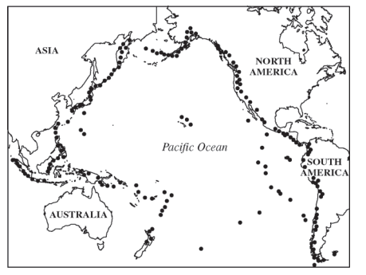
- FRQ sample- Plate tectonic theory states that the Earth’s lithosphere is broken into very slowly moving pieces or plates. Plate movements over vast stretches of time have led to the current orientation of our continents and oceans. Individual events along plate boundaries, such as earthquakes and volcanic eruptions, pose periodic threats to human activity and ecosystems. The “Ring of Fire” is a term that describes the location of increased seismic and volcanic activity around the margins of the Pacific Ocean basin. On the map above, each dot represents a volcano or an earthquake.
- Japan, Indonesia and the Philippines are examples of volcanic island chains that have formed along subduction zones between plates in the western Pacific.
- Describe what happens when two tectonic plates collide along a subduction zone.
ii. Explain how subduction leads to volcanic activity.

- Identify the following locations on the map above.
  - Area that exhibits island arcs
  - Area that exhibits a growing non-volcanic mountain chain due to uplift
  - Area where new crust is being created at a divergent plate boundary

- What causes seasons to occur in temperate zones?

- Describe how solar insolation shown at the right affects wind currents and precipitation patterns. 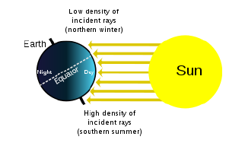

- On the world atlas below, label the following:
  - Equator
  - Arctic circle
  - Antarctic circle
  - Tropic of cancer
  - Tropic of Capricorn
  - Polar region
  - Temperate region
  - Tropic region
  - Northern Hemisphere
  - Southern Hemisphere
  - Label the major continents.
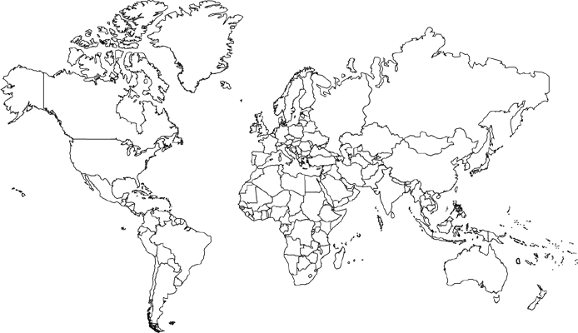

The Atmosphere
- Use the axes to the right for the following:
  - Draw a line representing the Earth’s atmosphere.
Altitude (km)
Temperature (°C)
  - Label each layer of the Earth’s atmosphere and identify where the greenhouse effect occurs and the ozone layer is situated.

- The box to the right contains a crude depiction of a mountain, use it to sketch and label the essential atributes of a rain shadow. Include labels for the direction of the prevailing winds and nearest ocean.

- Describe the following diagram of the Coriolis effect. How does the solar intensity and atmospheric convection currents influence the location of the major biomes?
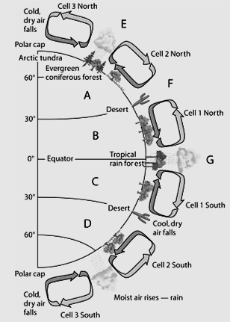

- Describe how the ocean currents, temperature and gas concentrations are directly related to those of the atmosphere.

- The acronym ENSO refers to _____________ _____________ _____________ _____________, a phenomenon that occurs in the _____________ Ocean.

- Using the following diagrams, explain what an El Niño event is and why it is significant.

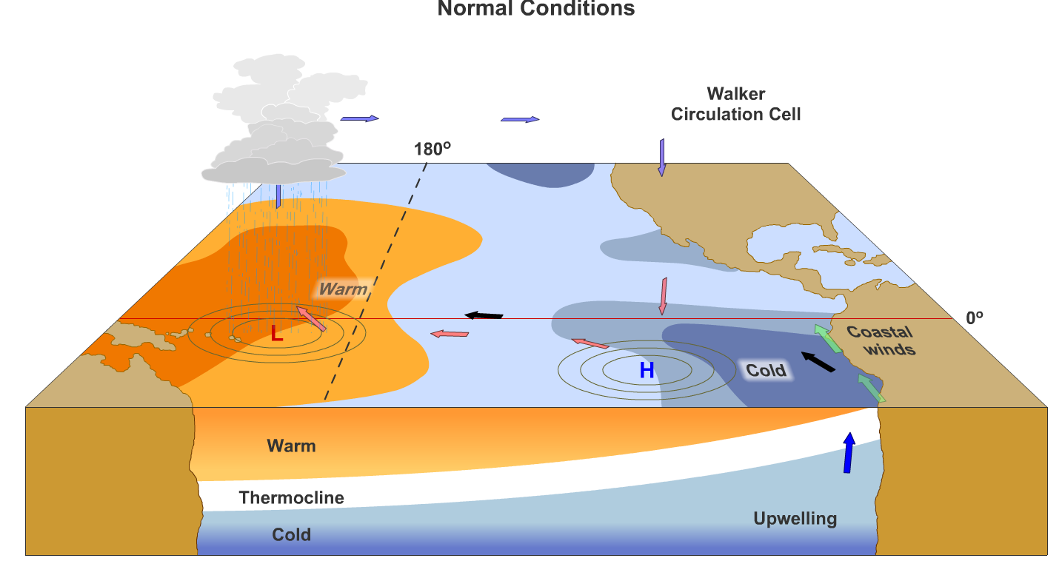
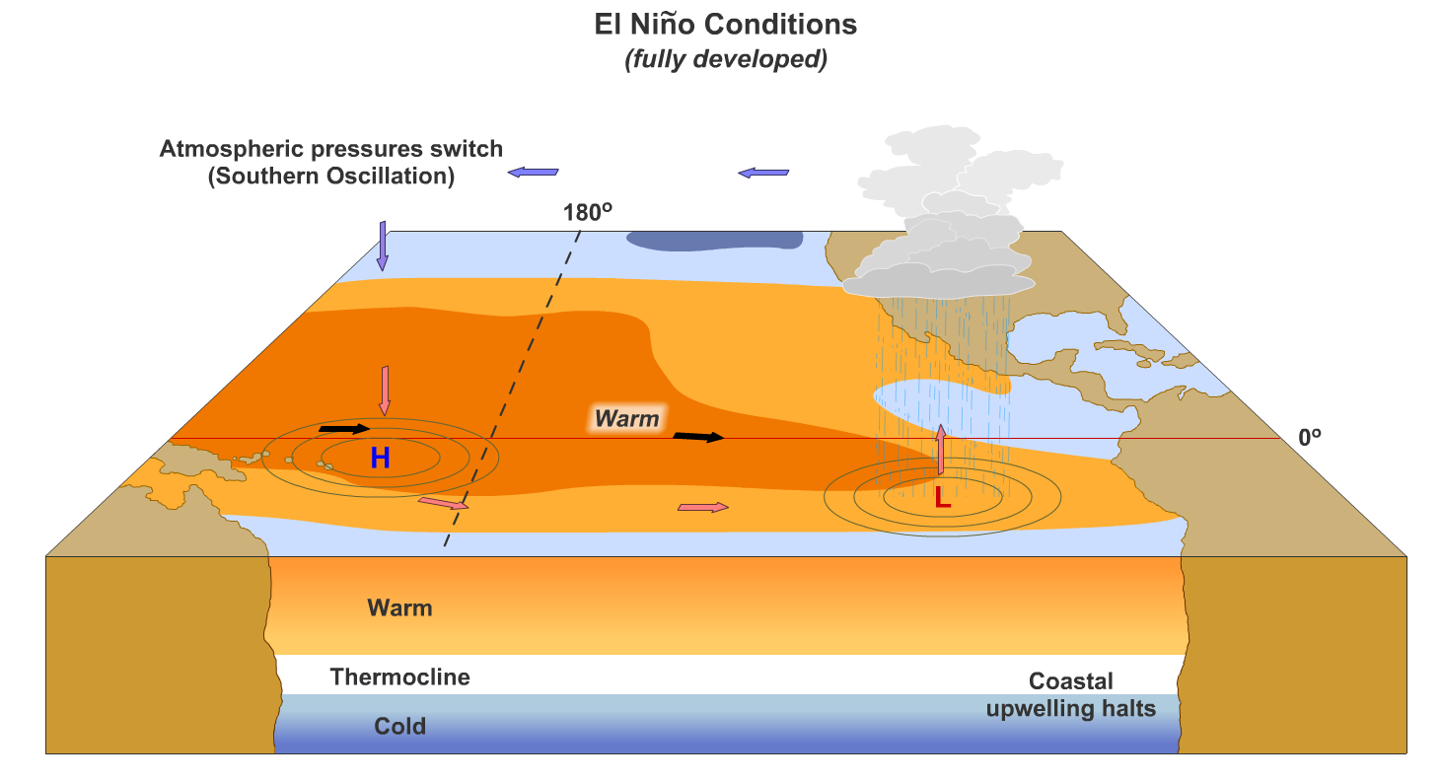

Global Water Resources and Use
- _____% of the Earth is covered with water. Of all the water on Earth _____% of it is saltwater, _____% is frozen, and _____% is available and relatively accessible.
- Explain what evapotranspiration is and why it is significant.

- Explain what a watershed is and why it is significant.

- For each of the following locations, explain what surface and groundwater issues occur there.

  - Colorado river basin
  - Ogallala Aquifer
  - Aral Sea

- Explain why freshwater is considered a(n):
  - Ecosystem service
  - Economic service
  - Global security issue
  - Natural capital

- List specific water conservation strategies for the following situations:
  - Irrigation in agriculture
  - Municipal use
  - Hydroelectric energy production
  - Industrial use

Soil and Soil Dynamics
- Explain the rock cycle. What are the three types of rocks and the forces that convert one form to another?

- Contrast the processes of weathering and erosion.
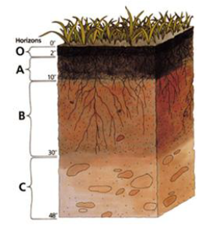
- Which horizon do you find the following layers? Add in a description of each:

  - Eluviation layer _________

  - Top soil __________

  - Parent material _______

  - Sub soil ________

  - Leaf litter _____

- Identify three examples organic compounds and three examples of inorganic compounds.
(1) (1)
Organic: (2) Inorganic: (2)
(3) (3)

- Arrange the following particles in order of smallest to largest: clay, sand, silt
(1) (2) (3)

- Explain how each of the following anthropogenic issues contribute to erosion
  - Agricultural practices
  - Urban development
  - River channelization
  - Deforestation
  - Mining

- Explain what human activities lead to
  - Desertification
  - Salinization
- What strategies can be used in the following issues to conserve soil nutrients while preventing erosion, desertification and/or salinization?
  - Agricultural practices
  - Urban development
  - River channelization
  - Deforestation
  - Mining

Part 2: Living World 10-15%

Vocabulary:

- abiotic
- adaptation
- aerobic respiration
- ammonification
- assimilation
- autotroph
- background extinction
- bacteria
- benthos
- biodiversity
- biogeochemical cycle
- biological diversity
- biome
- biosphere
- biotic
- deciduous plants
- carbon cycle
- carbon sink
- carnivore
- climax community
- coastal wetland
- commensalism
- community
- competitive exclusion
- coniferous trees
- coral reef
- deciduous plants
- decomposer
- denitrification
- detritivore
- detritus
- detritus feeder
- diffusion
- ecological diversity
- ecological niche
- ecology
- ecosystem
- endangered species
- endemic species
- energy productivity
- estuary
- evolution
- extinction
- fundamental niche
- first law of thermodynamics
- food chain
- food web
- freshwater life zones
- fundamental niche
- generalist species
- genetic diversity
- geographic isolation
- gross primary productivity (GPP)
- groundwater
- habitat
- herbivore
- heterotroph
- host
- hydrologic cycle
- indicator species
- infiltration
- interspecific competition
- intraspecific competition
- keystone species
- kilocalorie (kcal)
- law of conservation of energy
- law of conservation of matter
- leaching
- limiting factor
- mass extinction
- mutualism
- natural selection
- net energy
- net primary productivity (NPP)
- niche
- nitrogen cycle
- nitrogen fixation
- nitrification
- omnivore
- parasitism
- phosphorus cycle
- photosynthesis
- phytoplankton
- plankton
- pioneer species
- population
- precipitation
- predation
- primary consumer
- primary pollutant
- primary productivity
- primary succession
- producer
- pyramid of energy flow
- range
- range of tolerance
- realized niche
- reproductive isolation
- respiration
- resource partitioning
- riparian zones
- runoff
- scavenger
- second law of energy
- second law of thermodynamics
- secondary consumer
- secondary succession
- specialist species
- speciation
- species
- species eveness
- species diversity
- species richness
- sulfur cycle
- sulfur dioxide (SO2)
- sulfuric acid (H2SO4)
- surface runoff
- surface water
- terrestrial
- tertiary (higher-level) consumers
- theory of evolution
- transpiration
- trophic level
- water cycle
- water table
- zone of aeration
- zone of saturation

Review Questions:

A. Ecosystem Structure
  - Contrast what biotic and abiotic factors would be studied in a population, community and an ecosystem.

  - What types of factors would determine a species’ ecological niche? What is the purpose of a niche?

  - How do organisms use resource partitioning to avoid competition?

  - How does a species range of tolerance directly relate to competition?

  - For each of the following species interactions, define it and give a common example.
 | Definition | Example
Mutualism

Commensalism

Parasitism

Competition

Predation

  - Match the following:
  - generalist species Zebra mussel
  - specialist species Galapagos tortoise
  - invasive species American Alligator
  - keystone species Tiger salamander
  - indicator species Norway rat
  - endemic Species Giant Panda

  - Contrast genetic, ecosystem and species biodiversity.

  - If a forest is fragmented due to deforestation, explain how the edge effects impact species diversity and population sizes.

  - Fill out the chart below on the various biomes.
Type of Biome | Typical Location | Typical Climate | Characteristic adaptations for survival
Tropical Rain Forest |  |  | Plants –  Animals –
Temperate Deciduous Forest |  |  | Plants –  Animals –
Taiga (Boreal) Forest |  |  | Plants –  Animals –
Tropical Grasslands (Savanna) |  |  | Plants –  Animals –
Temperate Grassland (Prairie) |  |  | Plants –  Animals –
Tundra  (Cold Grassland) |  |  | Plants –  Animals –
Desert |  |  | Plants –  Animals –

  - What climatic patterns determines the type of biome an area will have?

  - For each of the following biomes, identify a specific country in which each biome occurs in relative abundance:
Taiga Desert
Tropical rainforest Temperate grassland
Tropical grassland Coral reef
Temperate deciduous forest Tundra

  - List two environmental benefits of wetlands.

  - Label the four major zones of life in the appropriate areas on the diagram representing a temperate lake in the box to the right.

  - Identify three examples of biotic components of an ecosystem and three examples of abiotic components of an ecosystem.
(1) (1)
Biotic: (2) Abiotic: (2)
(3) (3)

B. Energy Flow
  - Write the balanced chemical equation for photosynthesis in the box on the right.
Photosynthesis:

  - Write the balanced chemical equation for cellular respiration in the box on the right.
Cellular Respiration:

  - Perform the following calculation. Show all of your work. If the grasses on a 100-hectare area of grassland grow at an average rate of 1 cm/day, the average volume of grass that is added to the grassland each day is ____________ m³. If the density of the grasses that grow in the grassland averages 400 kg/m³, the net primary productivity is approximately _____________ g/m²/day or _____________ g/m²/year.
Show work:

  - On the following food web, classify each species into its trophic level.
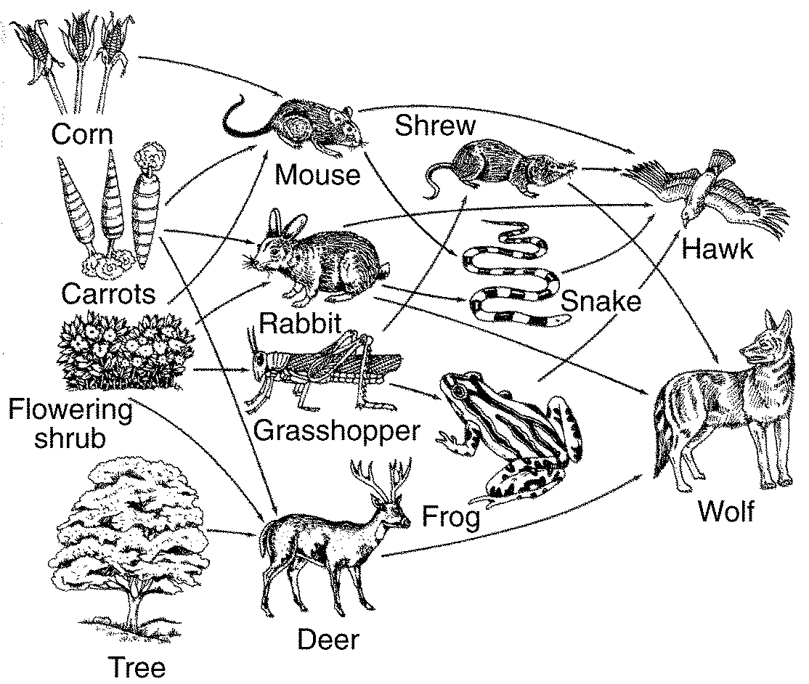
  - Next to the food web, draw an ecological pyramid using the food web above and determine the biomass of the deer if the wolf consumes 9643 kg.

  - Explain how the law of conservation of matter relates to the cycling of carbon through a food web.

  - Calculate net primary productivity of the tree if its Gross Primary Productivity is 56 mg O₂/L/day and its rate of respiration is 4 O₂/L/day.

C. Ecosystem Diversity
  - Explain how preserving biodiversity is directly related to the availability of natural capital.

  - Explain how biodiversity increases the survival of a species during the process natural selection and evolution.

  - Two islands, different distances from the mainland have different rates of extinction, this is explained by the theory of island ________________________.

  - Complete the following table:
Ecosystem Component | An economically valuable ecosystem services it provides
honey bee
water cycle
forest
bat
bacteria
coral reef
wetland

  - Strengthen this weak statement: “Protecting endangered species like the Giant Panda costs too much and should be stopped.”

  - Explain what evapotranspiration is and why it is significant.

D. Natural Ecosystem Changes
  - Describe how the following examples of climate shifts have impacted natural selection during Earth’s history.
Climatic shift | Impact on natural selection
Tectonic plate movement (Pangea)

Ice ages

Climatic warming

Island formation

Earthquakes/formations of canyons

  - Contrast primary and secondary ecological succession. What types of events cause each? Contrast the pioneer species found in each.

E. Natural Biogeochemical Cycles

  - Complete the following table for these biogeochemical cycles:
Trait | Carbon | Nitrogen | Phosphorus | Water
Importance to life
Largest reservoir
Methods of transport
Cycle duration (long/short)

  - Name the molecules that match each step of the nitrogen cycle: (FIXNAAD ANPAN)
Nitrogen fixation
Nitrification
Assimilation
Ammonification
Denitrification

Part 3: Population 10-15%

Vocabulary

- age structure
- agricultural revolution
- baby bust
- baby boom
- biotic potential
- birth rate
- carrying capacity (K)
- competitors
- cost-benefit analysis (CBA)
- crude birth rate
- crude death rate
- death rate
- debt-for-nature swap
- demographic transition
- demography
- density dependent factors
- density independent factors
- developed country
- developing country
- doubling time
- ecological footprint
- economy
- emigration
- environmental degradation
- environmental ethics
- environmental resistance
- environmentally sustainable economic development
- exponential growth
- external cost
- family planning
- famine
- fertility
- globalization
- green revolution
- gross domestic product (GDP)
- immigration
- industrial
- infant mortality rate
- K-strategists
- J-curve
- land degradation
- land-use planning
- less developed country (LDC)
- life expectancy
- limiting factor
- linear growth
- logistic growth
- malnutrition
- mass transit
- more developed country (MDC)
- natural capital
- opportunist
- overnutrition
- overshoot
- per capita GDP
- population density
- population dispersion
- population distribution
- population dynamics
- population momentum
- population size
- post industrial
- post- reproductive age
- poverty
- pre-industrial
- pre-reproductive age
- replacement-level fertility
- r-strategists
- rule of 70
- S- curve
- surplus
- survivorship curve
- total fertility rate (TFR)
- transitional
- tragedy of the commons
- undernutrition
- urban area
- urban growth
- urban sprawl
- urbanization

A. Population Biology Concepts
- Use the axes to the right for the following:
Population
Time
  - Draw and label a line that represents linear growth.
  - Draw and label a line that represents exponential growth.

- List the four most populated countries in the world.
- __________________________ (3)
- __________________________ (4)

- On the axes to the right, draw a line showing a population that exemplifies logistic growth. (s-curve) and label the carrying capacity.
Population
Time

- Perform the following calculation. Show all of your work. In a particular year a population has the following characteristics: the crude birth rate is 45, the crude death rate is 20, the immigration rate is 1%, and the emigration rate is 0.5%. The percent rate of growth for that year is __________.
Show work:

- List two characteristics of an r-selected species.
(1) (2)

- List two characteristics of a K-selected species.
(1) (2)
- Draw a survivorship curve for R- vs. K- selected species. Label the environmental resistance and biotic potential.

B. Human Populations
- In what regions of the world is population density the greatest concern? How is population distribution a food and water security issue?

- Explain two reasons why a population can continue to grow even if fertility rates decrease.

- Perform the following calculations: (Show all of your work in a logical progression to the final answer.)
  - A city has a population of 50,000 in 2012. If the population of the city grows at an annual rate of 2%, the year in which the population will reach 100,000 is _____________ and the year it will reach 200,000 is _____________.
Show work:

  - A country’s population was 12 million in 1992 and in 2012 it is 24 million. If the population grew at a constant rate, that percent rate of growth was _____________.
Show work:

- Write an equation for the rule of 70:

- Use the axes below to draw and label lines representing the birth rate, death rate and total population size during the idealized demographic transition of a country. Include, written directly onto the graph, an explanation for each change in the birth rate, death rate and total population size.
Rate / Population size
Time
- On the axes below, draw and completely label four age-structure diagrams that represent slow growth, rapid growth, negative growth, and zero population growth (include labels on the x- and y-axes)

- Complete the following table by writing “high” or “low” in each box below.
Characteristic | More Economically Developed Counties (MEDCs) | Less Economically Developed Countries (LEDCs)
per capita GDP
degree of industrialization
infant mortality rate
per capita fossil fuel use
ecological footprint
greenhouse gas emissions
risk from heart disease
risk from infectious diseases

- What was the Green Revolution and why is it important?

- Contrast the types of disease you find in developed countries versus undeveloped countries.

- How is the stage of demographics directly related to the economy of a country?

- Contrast resource use in each demographic stage.

- Describe some strategies for sustainability in urban regions.

- Contrast the national policies of the United States, China and India that directly impact the population growth rates of those countries.

Part 4: Land and Water Use 10-15%

Vocabulary

- Abyssal zone
- agricultural revolution
- agroforestry
- alley cropping
- anthropocentric
- aquaculture
- aquifer
- arable land
- area strip mining
- bathyal
- benthic zone
- benthos
- by-catch
- clear-cutting
- commercial inorganic fertilizer
- conservation
- conservationist
- conservation-tillage farming
- contour farming
- contour strip mining
- controlled burning
- conventional-tillage farming
- cost-benefit analysis (CBA)
- crop rotation
- desalinization
- Desertification
- Drainage basin
- Drift net fishing
- dredging
- drift-net fishing
- ecological restoration
- euphotic
- environmentalist
- environmentally sustainable economic development
- environmentally sustainable society
- erosion
- estuary
- euphotic zone
- eutrophic
- externalities
- feedlot (CAFO)
- fertility
- fertilizer
- fish farming
- fish ranching
- fishery
- food security
- fungicide
- genetically modified crops (GMO)
- globalization
- herbicide
- high-input agriculture
- human capital
- industrialized agriculture
- insecticide
- integrated pest management (IPM)
- intercropping
- interplanting
- land degradation
- land-use planning
- lentic
- limnetic zone
- littoral zone
- long line fishing
- low-input agriculture
- intertidal zone
- macronutrient
- malnutrition
- mangrove forest
- marine snow
- marsh
- mass transit
- micronutrient
- mineral resource
- minimum-tillage farming
- monoculture
- mountaintop removal
- natural capital
- natural recharge
- nekton
- no-till farming
- old-growth forest
- oligiotrophic
- open-pit mining
- ore
- organic fertilizer
- overfishing
- overgrazing
- overnutrition
- pasture
- pelagic
- persistence
- pest
- pesticide
- plankton
- polyculture
- polyvarietal cultivation
- purse seines
- profundal zone
- rangeland
- reforestation
- reserves
- restoration ecology
- salinity
- salinization
- second-growth forest
- selective cutting
- strip cropping
- strip cutting
- strip mining
- subsistence farming
- subsurface mining
- surface mining
- sustainable agriculture
- sustainable development
- sustainable living
- sustainable society
- sustainable yield (sustained yield)
- swamp
- tailings
- tar sand
- terracing
- thermal stratification
- tragedy of the commons
- undernutrition
- urban sprawl
- watershed
- water table
- wetland
- wilderness
- xeriscaping
- zone of saturation

Part 4- Review Questions- Land and Water Use

A. Agriculture
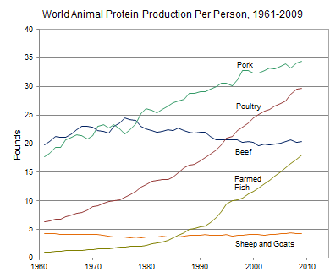
Use the information in the diagram on the left, to answer the following:
  - The percent change in the per capita global production of protein from poultry between 1980 and 2000 was approximately ________.
  - The percent change in the per capita global production of protein from farmed fish between 1980 and 2000 was approximately ________.
  - The percent change in the per capita global production of protein from beef between 1961 and 2009 was approximately ________.

  - Perform the following calculation. Show all of your work. If the grasses on a 100-hectare area of grassland grow at an average rate of 1 cm/day, the average volume of grass that is added to the grassland each day is ____________ m³. If the density of the grasses that grow in the grassland averages 400 kg/m³, the net primary productivity is approximately _____________ g/m²/day or _____________ g/m²/year.
Show work:

  - The acronym CAFO refers to _____________ _____________ _____________ _____________, which is important because:

  - What is different about growing plants hydroponically?

  - What was the Green Revolution and why is it important?

  - The acronym GMO refers to _____________ _____________ _____________, which is:

  - Arrange the following foods in order of highest to lowest in terms of global production: corn (maize); rice; wheat.
(1) (2) (3)

  - List four innovations that led to the Green revolution.
(1) (3)
(2) (4)
  - Explain what two issues can result from over- irrigation of crops in arid regions of the world.
  - What is a monoculture? What issues result from planting monocultures.
  - Explain four methods of sustainable agriculture practices that help reduce erosion and desertification.
  - Contrast industrial versus integrated pest management strategies of controlling pests.
  - What are the main types of pesticides? What does it mean when a pesticide is persistent?
  - What are the costs and benefits of pesticides use?
18. Explain what the FIRFA law protects you from.

B. Forestry
    - Perform the following calculations: (Show all of your work.)
A rectangular area of forest that measures 10 thousand meters by 300 thousand meters has an area of ___________ square kilometers and ___________ hectares.
Show work:

    - A company is importing rare tropical hardwood to manufacture furniture, list three laws, regulations, treaties, or acts that the company may have violated.
(1)
(2)
(3)
    - In terms of biodiversity, contrast the health of an old growth forest versus a tree plantation that has remediated a deforested region.

    - Describe the impact of natural forest fires on the health of a coniferous ecosystem. How have humans learned to manage controlled burns to maximize the fire’s benefits?

    - Describe the different methods of deforestation. Rank them from most damaging to forest health to least damaging.

24. Explain how national forest land is managed by the US Forest service. Would you consider this land a common? Why or why not?

C. rangelands
25. Explain how overgrazing can lead to desertification and a collapse of a grassland ecosystem. What methods are used to avoid this issue?

D. Other Land Use
26. For each of the following urban land development listed below, explain what issue(s) they create and what sustainable alternatives exist for each.
Urban land development | Issue | Sustainable alternative
Transportation infrastructure

Federal highway system

Canals and channels

- What economic and environmental issues are related to suburban sprawl?

- For each of the following public and federal lands, explain their purpose and challenges.
Public land | Purpose | Challenges
Wilderness areas

National parks

National Wildlife refuges

National Forests

Wetlands

Bureau of land management (BLM)

- Contrast the difference between the following land management techniques:
- Preservation
- Remediation
- Mitigation
- Restoration

E. Mining
- Explain where you find large reserves of the following mineral formations
- Coal
- Oil
- Natural gas

- Complete the following chart.
Mining Technique | Description | Environmental consequences
Open-Pit mining
Subsurface mining
Strip mining
Mountaintop removal
Drilling

- Strengthen this weak statement: “Mining causes pollution that may disrupt the environment.”

- What laws prevent mining issues such as acid drainage and the displacement of tailings?

F. Fishing
- ________________________ is a technique typically used to harvest scallops, crabs, and shrimp from the sea floor.

- Contrast the environmental impact of dredging, bottom trawling and longline fishing.

- Why is overfishing such a difficult issue to solve in our oceans? Explain the solutions or alternatives related to sustainable fishing practices.

- Explain the pros and cons related to aquaculture.

- What relevant laws and treaties prevent overfishing and preserve ocean species.

G. Global Economics
39. Explain the world bank and how it has helped reduce people overpopulation and issues related to poverty.

Part 5: Energy Resources and Consumption

- Active solar heating system
- Anthracite coal
- Biofuel
- biodiesel
- biomass
- bituminous coal
- breeder nuclear fission reactor
- clean coal
- coal
- coal gasification
- coal liquefaction
- cogeneration
- control rod
- coolant
- containment structure
- crude oil
- decommissioned
- energy
- energy efficiency
- energy productivity
- fuel rod
- fracking
- geothermal energy
- half-life
- Hydroelectric
- LEED program
- lignite
- liquefied natural gas (LNG)
- liquefied petroleum gas (LPG)
- natural gas
- nonrenewable resource
- nuclear fission
- nuclear fusion
- oil
- oil sands
- oil shale
- ore
- passive solar heating system
- peat
- petrochemicals
- petroleum
- photochemical
- photovoltaic cells (PV)
- radioactive waste
- reactor
- refining
- renewable resource
- shale oil
- solar energy
- solar thermal systems
- spent
- subsidy
- synfuels
- synthetic natural gas (SNG)
- tar sand
- tidal power
- turbine

Review Questions- Energy

A. Energy Concepts
      - Perform the following calculation. Show all of your work. A 40 m² solar array is installed on a house where the average insolation is 6 kWh/m²/day if the average total electricity output of the array is 1.2 kWh/hr; the efficiency of the array is ____________.
Show work:
      - A 60-Watt light bulb that is used for an average of 4 hours each day uses ___________ kilowatt-hours of electricity per year.
Show work:

      - If the cost of gas is $3.50 per gallon and the average gas mileage of a car is 25 mpg, the cost of driving the car per mile is _____________ $/mi, or _____________ ȼ/mi.
Show work:
      - When energy that is stored in fossil fuels are burned, it changes form. Explain, using the law of thermodynamics, how energy forms change and what happens to it during the chemical change.

B. Energy Consumption
      - Explain how the major types of energy use have changed in the following historical circumstances:
- Industrial Revolution

- Exponential growth of developing nations

      - Periods of energy crisis such as the gasoline shortage in 1970’s

      - At present, what are the top five types of energy used globally?

      - In the future, how will energy needs and sources expected to change?

C. Fossil Fuel Resources and Use

      - In the box to the right, list the ranks of coal in order from highest to lowest energy content. (indicate the direction in the box.)

      - List seven products that are derived primarily from crude oil:

      - Fracking is a common name for ______________ ______________ and it is a concern because…

      - The acronym ANWR refers to _____________ _____________ _____________ _____________, which is important because:

      - Perform the following calculations: (Show all of your work in a logical progression to the final answer.)
A family has a total of 1500 Watts of light bulbs throughout their house, if they replace them all with LED light bulbs, which use 90% less energy, the family will now use _____________ Watts of electricity.
Show work:

      - A space heater operates at 1500 Watts, if it is used for 10 hours each day for one week and the cost of electricity is 20 cents per kilowatt-hour, it will cost _____________ to operate the heater for the week.
Show work:

      - What are the advantages and disadvantages to using synfuels?

      - On the following chart, summarize the environmental advantages/disadvantages of each energy source
Energy source | Advantages | Disadvantages
Nuclear

Hydroelectric

Solar electricity

Hydrogen fuel cells

Biomass

Wind energy

Ocean waves and tidal energy

Geothermal

D. Nuclear Energy
- Explain how nuclear fission works.

- Explain how uranium is used to make electricity in a nuclear power plant.

- What are the safety issues associated with nuclear fission? How do nuclear power plants reduce those risks?

- Explain what happened at Fukushima and why it is significant?

- State where Chernobyl is located and explain what happened there.

- Perform the following calculation. Show all of your work. A radioactive cloud may contain Iodine-131, which has a half-life of 8 days. If the waste must decay to a concentration of less than 0.1% to be considered safe, it will take approximately ______ days to reach safe levels.
Show work:

- Perform the following calculation. (Show all of your work in a logical progression to the final answer.) A family has a 75 m² solar array on their house, which has an efficiency of 10%. If the average insolation on their array is 6 kWh/m²/day and their average cost of electricity is 20 cents per kilowatt-hour, the family has the capacity to produce _________ worth of electricity daily, and _________ annually, from the sun.
Show work:

- What are the issues related to radioactive wastes? Explain the controversy surround Yucca Mountain as a waste disposal site.

- Contrast nuclear fusion and nuclear fission.

E. Hydroelectric Power
- In the box to the right, draw a diagram that illustrates how electricity is produced by a dam

- How are hydroelectric power plants used for flood control? What issues are related concerning flooding and sediment at dams?

- How do hydroelectric power plants affect salmon populations? What strategies do they use to account for this?

- Explain the role of silting in a hydroelectric dam. How can that affect water quality?

F. Energy Conservation
- List four things you could do to conserve energy.
(1)
(2)
(3)
(4)

G. Renewable Energy
- List two species that may be threatened by the construction of a solar power tower in the California Desert.
(1) (2)

- ________________ is the active element in most photovoltaic cells.

- In the box to the right, sketch a house and the surroundings of a house that is designed to make the greatest use of passive solar energy in the northern hemisphere. Include, inside the box, the location of both the winter and summer sun, and labels to indicate the compass direction that the house faces.

Part 6: Pollution 25-30%

Vocabulary

- acid
- acid deposition
- advanced sewage treatment
- air pollution
- biological oxygen demand (BOD)
- biotic pollution
- broad spectrum agent
- carcinogen
- CERCLA (superfund act)
- Cultural eutrophication
- deep well disposal
- dissolved oxygen (DO) content
- dose response curve
- effluent
- environmental degradation
- Environmental Protection Agency (EPA)
- eutrophication
- environmental justice
- e-waste
- first generation pesticide
- fungicide
- genetic resistance
- greenhouse effect
- greenhouse gases
- hazardous waste
- herbicide
- incineration
- industrial smog
- industrial waste
- insecticide
- integrated waste management
- leachate
- LD50
- Materials recovery facility (MRF)
- Municipal solid waste (MSW)
- nitrogen oxides (NOx)
- noise pollution
- nondegradable pollutant
- nonpersistent pollutant
- nonpoint source
- open landfill
- oxygen-demanding wastes
- ozone (O3)
- ozone depletion
- ozone layer
- PANs
- particulates
- parts per billion (ppb)
- parts per million (ppm)
- parts per trillion (ppt)
- persistence
- persistent pollutant
- pest
- pesticide
- phytoremediation
- point source
- pollutant
- primary/closed loop recycling
- primary pollutant
- primary sewage treatment
- radon (Rn)
- risk assessment
- sanitary landfill
- second generation pesticide
- secondary pollutant
- secondary recycling
- secondary sewage treatment
- septic tank
- sludge
- smog
- solid waste
- subsidence
- subsistence farming
- surface impoundment
- temperature inversion
- thermal inversion
- turbidity
- toxicity
- toxicology
- volatile organic compounds (VOCs)

Pollution Review Questions

A. Pollution Types

Air pollution
  - Identify significant sources of the following air pollutants. Indicate if they are primary or secondary pollutants:
Formaldehyde:
Radon:
Mercury:
Carbon monoxide:
Nitrous oxide:

  - List three specific health effects of lead on humans.

  - Name the following:
SO_{X} N₂
NH₄⁺ NO_{x}
  - NO₂ is converted to N₂ and O₂ in a _____________ _____________, which also converts _____ to _____.

  - Explain the causes of an urban heat island.

  - In the area below, write a series of chemical reactions that leads to the formation of tropospheric ozone in photochemical smog.

  - For each of the following substances, draw an arrow that points to an unambiguous location along the line, below, representing pH: orange juice; normal rain; ammonia; lime (calcium carbonate); sulfuric acid; acid rain; human blood.

1 2 3 4 5 6 7 8 9 10 11 12 13 14
pH
  - Explain the cause of acid deposition and its major environmental effects

  - How are heat islands and temperature inversions formed? Why are they concerns related to smog?

  - Explain how ozone is “good up high but bad nearby”.

  - Why is indoor air pollution the most unregulated form of air pollution? What sources of indoor air pollution are the biggest issues?

  - Explain the remediation and reduction strategies for controlling radon in the home.

  - Explain the main components of the Clean Air Act and other relevant air pollution laws

Noise pollution
  - What are the sources, effects and control measures of noise pollution?

Water pollution
  - Explain how thermal pollution is produced by power plants.

  - Explain what a watershed is and why it is significant.

  - A family has a rectangular swimming pool that measures 15 feet by 20 feet. If water evaporates from the pool at a rate of 50 gallons per square foot per year and a pool cover will reduce evaporation by 90 percent, the family can save ___________ gallons of water per year by using a pool cover.
Show work:

  - List three things you could do to conserve water.
(1)
(2)
(3)

Perform the following calculations: (Show all of your work.)
  - A family of 5 replaces a 6-gallon/minute showerhead with a new 2-gallon/minute low-flow showerhead. If every member of the family takes one 10-minute shower per day, the family will save ___________ gallons of water in one year.
Show work:

  - Draw a diagram of cultural eutrophication below. Explain what water quality measurements are best at detecting eutrophication.

  - Groundwater pollution

  - Define the following:
pH:

Turbidity:

Water hardness: __________________________________________________________________________________________
_____________________________________________________________________________________________
Biological oxygen demand:

Organic waste:

  - List three disinfectants that are commonly used to make drinking water safe during in the water treatment process.
1) 2) 3)

  - Completely label the following diagram of a sewage treatment plant and list the items removed at each step.

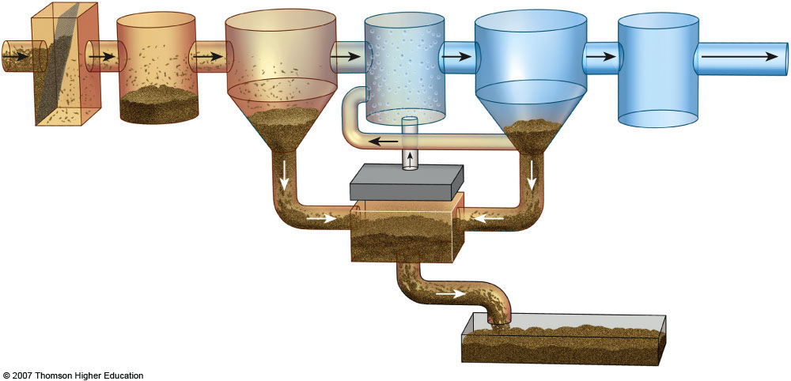
  - The acronym BOD refers to _____________ _____________ _____________, which is:

  - Define the following…
Watershed:

Clean Water Act:

Clean Drinking Water Act:

Solid Waste
  - List four characteristics that will result in waste being classified as “hazardous”

  - Contrast the benefits and disadvantages to disposing waste via:

    - Incineration
    - Sanitary landfill
    - Deep well injection
    - Surface impoundment

  - What are some reduction strategies used to reduce trash bulk and conserve materials? List them in order of greatest reduction to least.

  - The acronym NIMBY refers to _____________ _____________ _____________ _____________ _____________, which is:

B. Impacts on the Environment and Human Health

Hazards to human health
  - What factors are considered when determining the magnitude of an environmental risk?
  - Contrast acute and chronic effects of toxins. Which have more stringent laws governing them?
  - Contrast a threshold dose-response curve versus a non-threshold response. What is the difference?
  - What major air pollutants are considered hazards to human health? What human health issues do they cause?
  - What are the two main causes of lung cancer?

Hazardous chemicals in the environment
  - What are the main sources of hazardous wastes? How do we classify them?

  - Rachel Carson wrote the book ________ _________to raise people’s awareness of the harmful effects of the pesticide _______.

- Explain how the biomagnification of DDT led to the (near) demise of the Bald Eagle population in the US.

- Describe the treatment/disposal options for hazardous waste. What are their pros and cons?

- What branch of government is responsible for the cleanup and remediation of contaminated sites? What laws govern this process?

Part 7: Global Change (10 – 15%)

Vocabulary
- albedo
- anthropocentric
- artificial selection
- background extinction
- bioaccumulation
- biodiversity hotspots
- biological extinction
- biomagnification
- biotic pollution
- botanical garden
- captive breeding
- CITIES
- climate
- climate change
- cost-benefit analysis (CBA)
- drought
- endangered species
- endemic species
- ESA
- extinction
- feedback loop
- genetic engineering
- geographic isolation
- greenhouse effect
- greenhouse gases
- habitat fragmentation
- HIPPO (Habitat destruction, Invasive species, Pollution, Population, and Overharvesting)
- hydrologic cycle
- hydrosphere
- indicator species
- in situ
- invasive species
- keystone species
- Lacey Act
- mass extinction
- mitigation
- model
- monsoons
- mutations
- natural greenhouse effect
- natural rate of extinction
- natural selection
- negative feedback loop
- non-native species
- overexploitation
- ozone (O3)
- ozone depletion
- ozone layer
- poaching
- pollution
- positive feedback loop
- preservation
- rehabilitation
- remediation
- restoration
- reproductive isolation
- second growth forests
- seed bank
- speciation
- species richness
- threatened species
- urbanization
- wildlife refuge

Review Questions- Global Change

A. Stratospheric Ozone
  - The molecular formula of ozone is ________.

  - In the box below, write out a series of chemical equations that illustrate the destruction of the ozone in the ozone layer.

  - The acronym HCFC refers to _____________ _____________ _____________ _____________, which is:

  - Explain the dangers related to too much exposure to ultraviolet radiation.

  - What are the environmental and economic effects of ozone depletion.

  - What strategies and laws/treaties have reduced ozone depletion? Why do the effects of remediation take so long to occur?

B. Global Warming
  - List three consequences of global warming.
(1)
(2)
(3)

  - List three things you could do to decrease your contribution to global warming.
(1)
(2)
(3)
  - List four greenhouse gases.
(1) (3)
(2) (4)

  - Contrast the layers of the atmosphere, the molecules involved and the type of radiation involved in ozone depletion and global warming.

  - Describe an example of a positive feedback loop.

  - Describe an example of a negative feedback loop.

  - What are the relevant laws and treaties that have attempted to solve climate change? Why is climate change so difficult to solve?

C. Loss of Biodiversity
  - Give examples of organisms affected by the loss of biodiversity due to:
Habitat loss
Overuse
Pollution
Introduced species
Endangered and extinct species

  - Strengthen this weak statement: “Protecting endangered species like the Giant Panda costs too much and should be stopped.”

  - What relevant laws and treaties are used to protect species from loss of diversity?

CASE STUDY CONNECTIONS

Week 1 Current event: _____________________________________________________
Current Event Summary

Math Practice

Relevant definitions

Thursday: Assess Sustainability
economy
society
environment

Friday: FRQ Practice
________________________________________________________________________________________________________________________________________________________________________________________________________________________________________________________________________________________________________________________________________________________________________________________________________________________________________________________________________________________________________________________________________________________________________________________________________________________________________________________________________________________________________________________________________________________________________________________________________________________________________________________________________________________________________________________________________________________________________________________________________________________________________________________________________________________________________________________________________________________________________________________________________________________________________________________________________________________________________________________________________________________________________________________________

Week 2 Current event: _____________________________________________________
Current Event Summary

Math Practice

Relevant definitions

Assess Sustainability
economy
society
environment

FRQ Practice
________________________________________________________________________________________________________________________________________________________________________________________________________________________________________________________________________________________________________________________________________________________________________________________________________________________________________________________________________________________________________________________________________________________________________________________________________________________________________________________________________________________________________________________________________________________________________________________________________________________________________________________________________________________________________________________________________________________________________________________________________________________________________________________________________________________________________________________________________________________________________________________________________________________________________________________________________________________________________________________________________________________________________________________________

Week 3 Current event: _____________________________________________________
Current Event Summary

Math Practice

Relevant definitions

Assess Sustainability
economy
society
environment

FRQ Practice
________________________________________________________________________________________________________________________________________________________________________________________________________________________________________________________________________________________________________________________________________________________________________________________________________________________________________________________________________________________________________________________________________________________________________________________________________________________________________________________________________________________________________________________________________________________________________________________________________________________________________________________________________________________________________________________________________________________________________________________________________________________________________________________________________________________________________________________________________________________________________________________________________________________________________________________________________________________________________________________________________________________________________________________________

Week 4 Current event: _____________________________________________________
Current Event Summary

Math Practice

Relevant definitions

Assess Sustainability
economy
society
environment

FRQ Practice
________________________________________________________________________________________________________________________________________________________________________________________________________________________________________________________________________________________________________________________________________________________________________________________________________________________________________________________________________________________________________________________________________________________________________________________________________________________________________________________________________________________________________________________________________________________________________________________________________________________________________________________________________________________________________________________________________________________________________________________________________________________________________________________________________________________________________________________________________________________________________________________________________________________________________________________________________________________________________________________________________________________________________________________________

Week 5 Current event: _____________________________________________________
Current Event Summary

Math Practice

Relevant definitions

Assess Sustainability
economy
society
environment

FRQ Practice
________________________________________________________________________________________________________________________________________________________________________________________________________________________________________________________________________________________________________________________________________________________________________________________________________________________________________________________________________________________________________________________________________________________________________________________________________________________________________________________________________________________________________________________________________________________________________________________________________________________________________________________________________________________________________________________________________________________________________________________________________________________________________________________________________________________________________________________________________________________________________________________________________________________________________________________________________________________________________________________________________________________________________________________________

Week 6 Current event: _____________________________________________________
Current Event Summary

Math Practice

Relevant definitions

Assess Sustainability
economy
society
environment

FRQ Practice
________________________________________________________________________________________________________________________________________________________________________________________________________________________________________________________________________________________________________________________________________________________________________________________________________________________________________________________________________________________________________________________________________________________________________________________________________________________________________________________________________________________________________________________________________________________________________________________________________________________________________________________________________________________________________________________________________________________________________________________________________________________________________________________________________________________________________________________________________________________________________________________________________________________________________________________________________________________________________________________________________________________________________________________________

Must-Know Math Review
Things to know…..  Million= 10⁶  Billion= 10⁹  Mega= 10⁶ (ex: 1,000,000 BTU/ 1 MBTU)  Kilo= 10³ (ex: 1000 watts/ 1 kW)  Half Life  1 1/2 1/4 1/8 1/16 1/32 1/64 | Population Stuff….  Approximate population for:  The world: 7.5 billion  China: 1.3 billion  India: 1.3 billion  The US: 325 million  Per Capita = Per Person
Percent  Percent is part divided by the whole times 100!  Primary Productivity  Gross primary productivity - respiration = net primary productivity | Population Math  Population Density=  Number of individuals/ area  Growth Rate is a %  B-D/ population size * 100  Rule of 70  DT = 70/ GR
Percent Change  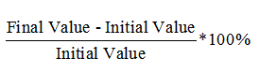  N-O  O | ENERGY  KWh= kilowatts * hours  Efficiency can be solved using ratios
ALWAYS! EVERYTIME!
SHOW YOUR WORK!
Numbers must be labeled in the SET-UP (Use dimensional analysis!)
Your numbers will be neat!
If you can’t use scientific notation, count your zeroes when you multiply and reduce them when you divide. Double check!!
Always make sure your answer makes sense!
Label and identify your answers clearly!
